*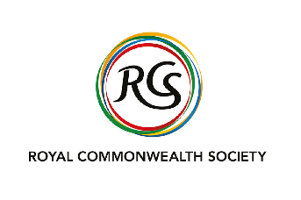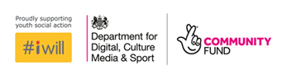****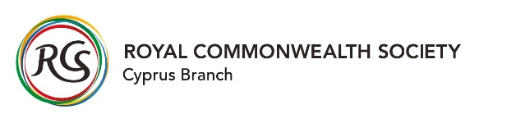***

***Social Action Youth Exchange Programme 2020-2021***

***‘From Local to Global’***

*Inspiring young leaders to serve as catalysts for peace and social justice in their local communities and throughout the world.*

*This will be an opportunity to discover another culture, and truly become global citizens.*

**About the programme**

[The Royal Commonwealth Society (RCS)](https://www.royalcwsociety.org/), in partnership with Clarion Futures, invites eligible individuals to apply for an exciting youth exchange programme, which is designed to foster connections between young people in the UK and Cyprus.

The main aim is to promote positive values, share learning on the global issue of COVID-19 on young people, and lead on social action projects that can change the world.

The exchange programme will enable a wide variety of young people to come together in England and Cyprus with a common purpose: building and maintaining connected communities during and post the COVID-19 crisis. Participants will then share the knowledge acquired through this experience with their networks on their return.

The exchange will be structured as follows:

|  |  |  |  |  |  |
| --- | --- | --- | --- | --- | --- |
| **Oct 2020** | **Nov-Dec 2020** | **Jan-March 2021** | **April 2021** | **July 2021** | **Aug-Sept 2021** |
| Recruitment of participants | Online introductory sessions &  4-day, virtual training programme | Campaigns/ social action projects and virtual meetings/ check-ins | International Exchange in Cyprus & Knowledge Sharing | Celebration Youth Event and International Exchange in the UK | Legacy work: Social Action Plans |
| 12 Month Programme | | | | | |

**What are the costs?**

Costs for participating in the programme, including flights, accommodation, meals and other logistical expenses relating to the international exchanges, will be met by the RCS, Clarion Futures and their partner, donor organisations and individuals. Bursaries to assist with the delivery of qualifying Social Action Plans will also be considered.

**How can I apply?**

Please submit your answers to the following questions to express an interest in joining our Social Action Youth Exchange Programme. Please send your answers on the below application form to [**communications@royalcwsociety.org**](mailto:communications@royalcwsociety.org). **The deadline for applications is 17:00 GMT, Tuesday 27th October 2020.**

All applications will be acknowledged, and a member of the team will contact you if you have been successful to arrange an informal interview and provide you with more information about the programme. Please note that individual feedback will not be provided for unsuccessful applications.

Please note all participants should be:

* 18-25 years old;
* Passionate about creating positive change in your community;
* Have some previous experience of engaging in social action, volunteering or activism;
* Knowledge of grassroots organisations and social action opportunities in your local area;
* Knowledge of young people in your community and the issues that affect them;
* Good communication skills;
* Enjoy meeting new people and would be excited to attend a 4-day online training programme in December, and a 5-day Youth Exchange in Cyprus;
* An active team member who will commit to attending all meetings and virtual training/exchange activities, as well as participate in the programme for a 12-month period.

Please submit answers to these questions by typing your answers in the boxes or answering the questions on a video recording of yourself. Because good communication and energy are such important parts of this role, we will take into account any videos received. This doesn’t need to be a Hollywood production; something recorded on your phone is fine. The video should be no longer than 5 minutes, using the questions below as inspiration. Please also send us your CV if you have one.

We are recruiting for 10 exchange participants, with a start in early November for a 12 month period.

***1. Please tell us about yourself (Name, age, where about you live, any hobbies…)***

|  |
| --- |
|  |

***2. Why are you are interested in this exchange programme? Why would you be a great addition to the programme?***

|  |
| --- |
|  |

***3. Please give an example of something you have done that demonstrates your passion for social action and improving communities for the better. This may be a work opportunity, volunteering experience or something you have done in your local community.***

|  |
| --- |
|  |

***4. Please give an example of how you would engage young people to connect and run social action activities in your community? Would you approach certain youth groups or organisations, schools or neighbourhood offices (e.g. CAP, LGBT, BAME youth group, Scouts, Dance Groups, Youth Parliament, Steering Group, etc.)?***

|  |
| --- |
|  |

***5. Please tell us about your current situation (e.g. are you working, studying, volunteering, a carer or taking some time out?)***

|  |
| --- |
|  |

**6. *Have you ever participated in an abroad exchange (e.g. trip with a community group, scouts or your school)?***

|  |
| --- |
|  |

**7. *What is an issue that your community cares about (e.g. how has COVID-19 affected the young people in your local area)?***

|  |
| --- |
|  |